**Lab 1**

**Name:** Etcherla Sai Manoj **Mis. No:** 112015044 **Branch:** CSE

**Question1:**

**Code:**

#include<iostream>

using namespace std;

class beta;

class alpha

{

int num1;

public:

void a_setvalue(){

cout << " Enter a number : ";

cin >> num1;

}

friend void add(alpha, beta);

};

class beta

{

int num2;

public:

void b_setvalue(){

cout << "Enter another number : ";

cin >> num2;

}

friend void add(alpha, beta);

};

void add(alpha a, beta b){

cout << "The sum of numbers is : " << a.num1 + b.num2;

}

int main(){

alpha a; beta b;

a.a_setvalue();

b.b_setvalue();

add(a,b);

return 0;

}

**Input & Output:**



**Question2:**

**Code:**

#include<iostream>

using namespace std;

class Sam

{

int a,b;

void add(){

cout << "Sum of Two numbers : " << a+b;

}

public:

void getdata(){

cout << "Enter two numbers : ";

cin >> a; cin >> b;

}

friend class Tom;

};

class Tom

{

public:

void access(Sam x){

x.add();

}

};

void add(){

}

int main(){

Sam s; Tom t;

s.getdata();

t.access(s);

return 0;

}

**Input & Output:**



**Question3:**

**Code:**

#include<iostream>

#include<cstring>

using namespace std;

class Student

{

string Name;

int Rollno;

char Section;

public:

void add(Student s){

cout << "Enter Name : " ;cin >> Name;

cout << "Enter Roll.No.: " ;cin >> Rollno;

cout << "Enter Section : " ;cin >> Section;

}

void show(Student s){

cout << "\n---------------------------------------------\n";

cout << "***Details of Student***" << endl;

cout << "Name : " << Name << endl;

cout << "Roll No.: " << Rollno << endl;

cout << "Section : " << Section << endl;

cout << "\n---------------------------------------------\n";

}

};

int main(){

Student z,s1;

z.add(s1);

z.show(s1);

return 0;

}

**Input & Output:**

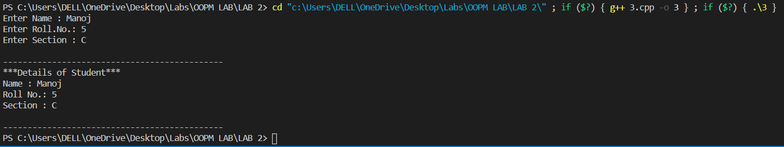

**Question4:**

**Code:**

#include<iostream>

using namespace std;

class Student

{

public:

string Name;

int Rollno;

float marks;

};

class Marksheet

{

public:

Student obj[5];

void addSMark(){

for(int i = 0; i < 5; i++){

cout << "Enter Name: ";

cin >> obj[i].Name;

cout << "Enter Roll.No.: ";

cin >> obj[i].Rollno;

cout << "Enter marks : ";

cin >> obj[i].marks;

}

}

void showMark(int r){

for(int i = 0; i < 5; i++){

if(obj[i].Rollno == r){

cout << "\n------------------------------------------------\n";

cout << "***Details of Student***" << endl;

cout << "Name : " << obj[i].Name << endl;

cout << "Roll No.: " << obj[i].Rollno << endl;

cout << "Section : " << obj[i].marks << endl;

cout << "------------------------------------------------";

}

}

}

};

int main(){

Marksheet m1;

m1.addSMark();

m1.showMark(5);

return 0;

}

**Input & Output:**

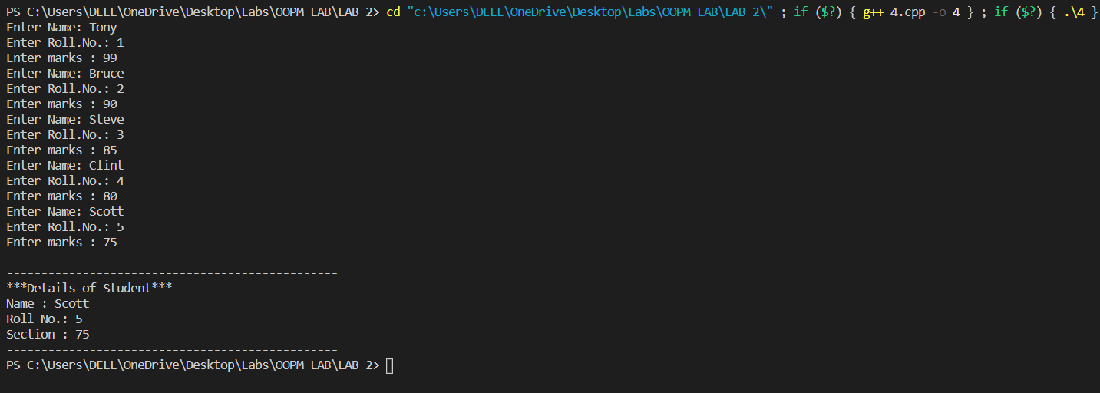

**Question5:**

**Code:**

#include<iostream>

using namespace std;

class Complex

{

int a, b;

public:

void getvalue(int x, int y){

a = x;

b = y;

}

void printvalue(){

cout << "Complex Number is : " << a << "+" << b <<"i" << endl;

}

friend Complex csum(Complex c1, Complex c2);

};

Complex csum(Complex c1, Complex c2){

Complex c3;

c3.getvalue((c1.a + c2.a),(c1.b + c2.b));

return c3;

}

int main(){

Complex C1, C2, sum;

C1.getvalue(2,8);

C2.getvalue(5,7);

sum = csum(C1, C2);

sum.printvalue();

return 0;

}

**Input & Output:**

